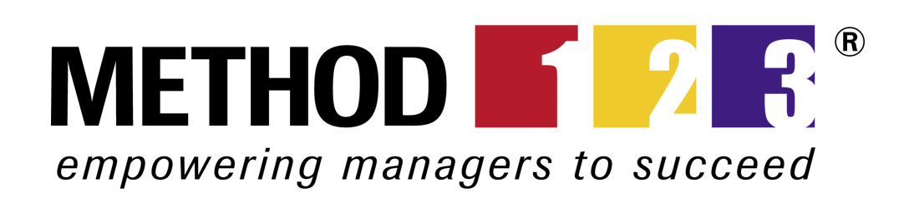

Feasibility Study©
For [Project Name]

Document Control

Document Information
© | Information
Document Id | [Document Management System #]
Document Owner | [Owner Name]
Issue Date | [Date]
Last Saved Date | [Date]
File Name | [Name]

Document History
Version | Issue Date | Changes©
[1.0] | [Date] | [Section, Page(s) and Text Revised]

Document Approvals
Role | Name | Signature | Date
Project Sponsor

Project Review Group

Project Manager©

Quality Manager
(if applicable)

Procurement Manager
(if applicable)

Communications Manager
(if applicable)

Project Office Manager
(if applicable)

Table of Contents

Template Guide 1
1 Executive Summary 2
2 Problem Statement 2
2.1 Business Environment 2
2.2 Business Problem 3
3 Requirements Statement 4
3.1 Business Drivers 4
3.2 Business Requirements 4
4 Feasibility Assessment 4
4.1 Option 1 – [Option Name] 6
4.1.1 Description 6
4.1.2 Assessment 6
4.1.3 Results 6
4.1.4 Risks 7
4.1.5 Issues 7
4.1.6 Assumptions 8
4.2 Option 2 – [Option Name] 8
4.2.1 Description 8
4.2.2 Assessment 8
4.2.3 Results 8
4.2.4 Risks 8
4.2.5 Issues 8
4.2.6 Assumptions 8
4.3 Option 3 – [Option Name] 8
4.3.1 Description 8
4.3.2 Assessment 8
4.3.3 Results 8
4.3.4 Risks 8
4.3.5 Issues 8
4.3.6 Assumptions 8
5 Feasibility Ranking 9
5.1 Ranking Criteria 9
5.2 Ranking Scores 9
6 Feasibility Result 9
7 Appendix 9
7.1 Supporting Documentation 9

Template Guide
What is a Feasibility Study?

A Feasibility Study is a document which identifies each of the solution options available and rates the likelihood of each option achieving the desired result. It includes:

- A full description of the business problem (or opportunity)
- A list of the requirements for a solution to fix the problem (or realize the opportunity)
- Available options for delivering a solution
- An assessment of the feasibility of each option
- A list of the risks and/or issues associated with each option
- A preferred option to be approved for implementation. ©

When do I use a Feasibility Study?

The Feasibility Study is typically presented by Senior Management within the business to an identified Business Sponsor. Although it may be conducted prior to, during or after the completion of a Business Case, it is usually undertaken as part of the overall Business Case process to add more rigor to the solution options presented in the Business Case. For this reason, the topics defined in both the Business Case and Feasibility Study documents are similar.
The main purpose of the Feasibility Study is to ascertain the likelihood of each solution option identified for meeting the stated business requirements. Although the risks, issues and constraints are important, the project is less likely to be a success if the solution option chosen is unlikely to be feasibly implemented.

To determine the likely feasibility of an option, a range of ‘assessment’ methods is undertaken. As there is a myriad of potential methods available to assess feasibility, we suggest you take time to consider the most appropriate method available to your project. The outcome of the Feasibility Study is a confirmed solution option for inclusion within the Business Case. The next stage, after the solution option has been approved, is to define the project scope and structure within a project Terms of Reference document. ©

NB A Feasibility Study may address a business problem to be resolved, or a business opportunity to be realized. Although this document refers frequently to the resolution of ‘business problems’, each section equally applies to the realization of ‘business opportunities’ as well.

How to use this template
This document provides a guide on the topics usually included in a Feasibility Study document. Sections may be added, removed or redefined at your leisure to meet your particular business circumstance. Example tables, diagrams and charts have been added (where suitable) to provide further guidance on how to complete each relevant section.

Executive Summary

Summaries each of the sections in this document into short concise points by outlining the:

- Problem or opportunity
- Project requirements
- Feasibility assessment results
- Overall outcome.

Problem Statement

Business Environment
Describe the business environment which contains the business problem (or opportunity), as follows:

External Analysis
Outline the external environment within which the business operates by defining the:

- Market segment, competition, products and services available
- New market, technology, and commercial or operational trends
- Statutory or legislative changes. ©

Business Vision
Outline the business vision, strategy or objectives for the short, medium and long term.

Business Units
List each of the current business units (e.g. Finance Department) relevant to this project. Depict the business units within an Organization Chart to highlight business reporting and internal communication lines.

Business Locations
Document the physical location (i.e. street address) of each business unit relevant to this project. If necessary, depict business locations within a Geographical Map to highlight the physical placement of each business unit.

Business Information
Identify the major types of business ‘information’ (i.e. summarized data) utilized. List the repositories which retain the information listed (e.g. financial database). Depict the information and source repositories within a Data Flow Diagram.

Business Technologies
List each of the current business technologies (e.g. IBM Mainframe) relevant to this project. Provide a description for each major technology. Depict all business technologies within a Technology Architecture Diagram to highlight the interfaces between current business technologies.

Business Processes
List each of the current business processes relevant to this project. Provide a description for each major business process. Depict all business processes within a Process Flow Diagram to highlight the flow of processes (e.g. payments process).

Business Problem

Business Problem

Describe in detail the core business problem to be addressed, including:

- A full description of the core problem
- The reasons why the problem exists
- The impact it is having on the business (financial, cultural, operational)
- The timeframes within which it must be resolved.

Examples may include business problems related to:

- Business Process
  - efficiency, timeliness, ownership
- clarity, accuracy, relevancy. ©
- Business Unit
  - definition (lack of vision, scope, objectives)
  - direction (misalignment with corporate vision)
  - structure (inefficient / inappropriate structure)
  - size (too large / too small) and makeup (skills, experience)
  - performance (product / service quality)
  - data (quality).
- Business Location
- security (exposure, risks)
- relevancy (does not fit corporate image)
- finances (too expensive)
- physical appearance (deterioration).
- Business Technology
- reliability, scalability, and performance
- relevancy (i.e. fit to business objectives).

Business Opportunity

Describe the opportunity which has been identified, including:

- A full description of the opportunity
- Supporting evidence to confirm that the opportunity exists
- The timeframe for which the opportunity will likely exist
- The positive impact that realizing the opportunity will have on the business.

Example of business opportunities include:

- New market demand identified
- Competitor company failure or change
- New ideas for products or services
- New business premises made available
- New technologies available for usage
- New skill-sets available in market
- Changes in legislation or regulatory requirements.

Requirements Statement

Business Drivers
List the key ‘business drivers’ for this project. Examples include:

- A particular business objective which must be achieved within a certain period
- Changes to legislation / regulation which come into effect on a certain date
- A limited timeframe for competitive advantage
- Timing of other related changes in the business or external market-place. ©

Business Requirements
For each business problem (or opportunity) identified above, document the detailed business requirements, using the following table:

Problem / Opportunity© | Requirement
Description | Description

A ‘requirement’ is an identifiable business need for a solution. Examples include:
- A new process to be implemented which improves business efficiency by 50%
- The establishment of a new business unit to deliver a new product to the market
- New building premises providing 75% more capacity
- A financial management system which provides payroll functionality
- A stable technology platform which consistently achieves 99.5% availability. ©

Feasibility Assessment

This section assesses and identifies each of the solutions options available and the ‘feasibility’ (or likelihood) of each option meeting the requirements defined above. It also describes the risks, issues and assumptions associated with the feasibility of each option. The typical process for assessing the feasibility of an individual solution is depicted by the following diagram:

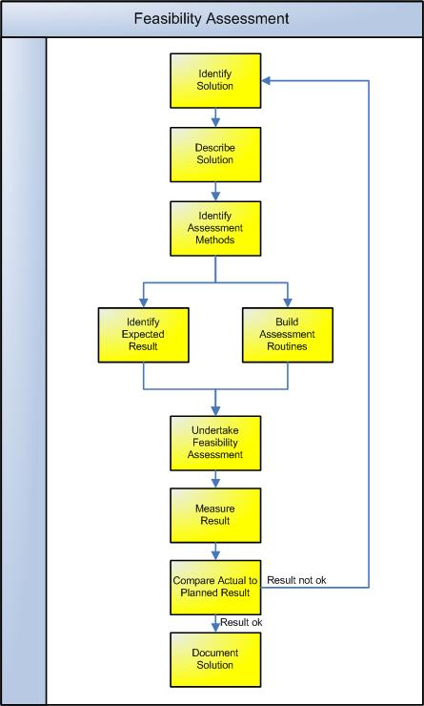

Undertake the above process to identify the potential solution options and their level of feasibility. Once the process is complete, document the result as follows:

Option 1 – [Option Name]
    - Description
Provide a detailed description of the solution, including:

- A list of the components which make up the solution
- A description of the purpose of each component identified
- An explanation of how this particular component addresses the key business requirements identified above.

    - Assessment
Outline the methods utilized to assess the feasibility of the solution. For example:

- Prototyping. A prototype is a subset of the full solution which is constructed to prove that at least part of the full solution is achievable. Prototypes are typically developed to prove that the highest risk areas of the solution are feasible. For instance, if the solution involves the implementation of a new financial system, a prototype may be built to test that the package can be integrated with other application systems used in the business
- Staff surveys. Staff Surveys are a good method for identifying the feasibility of solutions which involve changes in business processes. For instance, they may be used to identify the likely success of a new Performance Management Process
- Market surveys. Market Surveys may be undertaken to assess the feasibility of introducing new products / services to the market by determining likely market demand. ©

In some cases it may not be practical to undertake formal methods for the assessment of feasibility. Careful consideration and a ‘best guess’ may be the only method available.

    - Results
Describe the overall result of the assessment by:

- Documenting the expected vs. actual result
- Scoring the expected vs. actual result
- Listing other (typically non-tangible) feasibility considerations (e.g. cultural changes required) which also need to be taken into account in the final rankings.

    - Risks
List the apparent risks associated with the implementation of this solution. Risks are defined as “any event which may adversely affect the ability of the solution to produce the required deliverables”. Risks may be Strategic, Environmental, Financial, Operational, Technical, Industrial, Competitive or Customer related. Complete the following table:

Description© | Likelihood | Impact | Mitigating Actions
Inability to recruit skilled resource | Low | Very High | Outsource project to a company with proven industry experience and appropriately skilled staff
Technology solution is unable to deliver required results | Medium | High | Complete a pilot project to prove the full technology solution
Additional capital expenditure may be required in addition to that approved | Medium | Medium | Maintain strict capital expenditure processes during the project

To complete this section thoroughly, it may be necessary to undertake a formal Risk Assessment (by documenting a Risk Management Plan). To improve the likelihood and impact of each risk eventuating, clear ‘mitigating actions’ should be defined. Furthermore, a clear Risk Management Process (including Risk Forms and Registers) should be used from the outset.

    - Issues
List the issues associated with the adoption of this option. Issues are defined as “any event which currently adversely affects the ability of the solution to produce the required deliverables”. Complete the following table:

Description | Priority | Resolution Actions©
Required capital expenditure funds have not been budgeted | High | Request funding approval as part of this proposal
Required computer software is only at ‘beta’ phase and has not yet been released live | Medium | Design solution based on current software version and adapt changes to solution once the final version of the software has been released
Council approval must be sought to implement the final solution | Low | Initiate the council approval process early so that it does not delay the final roll-out process.

    - Assumptions
List the assumptions associated with the adoption of this solution. For example:

- There will be no legislative, business strategy or policy changes during this project
- Prices of raw materials will not increase during the course of the project
- Additional human resources will be available from the business to support the project.

Option 2 – [Option Name]
    - Description
As defined above in Section 4.1.1
    - Assessment
As defined above in Section 4.1.2
    - Results
As defined above in Section 4.1.3
    - Risks
As defined above in Section 4.1.4
    - Issues
As defined above in Section 4.1.5
    - Assumptions
As defined above in Section 4.1.6

Option 3 – [Option Name]
    - Description
As defined above in Section 4.1.1
    - Assessment
As defined above in Section 4.1.2
    - Results
As defined above in Section 4.1.3
    - Risks
As defined above in Section 4.1.4
    - Issues
As defined above in Section 4.1.5
    - Assumptions
As defined above in Section 4.1.6

Feasibility Ranking

Ranking Criteria
List the criteria used to rank the options identified and describe the scoring / weighting mechanism used to produce an overall result.

Ranking Scores
Score each option by completing the following table:

 | Option 1 |  |  | Option 2 |  |  | Option 3
Criteria© | Score | Weight | Total | Score | Weight | Total | Score | Weight | Total
- Criteria 1
- Criteria 2
- Criteria 3
- Criteria 4
- Criteria 5
- Criteria 6
- Criteria 7
- Criteria 8
- Criteria 9
- Criteria 10

Total Score

NB. The Score is typically a number from 1 (low feasibility) to 10 (high feasibility) and the Weight a number from 0.5 (criterion is unimportant) and 1.5 (criterion is very important). The Total is calculated as Score * Weight. ©

Feasibility Result

Based on the “Total Score” result, identify the option which has achieved the highest total score and is therefore the ‘Most Feasible’ option for implementation. Summarize the key reasons why this option is most likely to meet the identified business requirements.

Appendix

Supporting Documentation
Attach any documentation you believe is relevant to the Feasibility Study, including:

- Business vision, strategy and objective statements
- Market research documents and statistics
- Detailed problem analysis and requirements' documentation
- Detailed feasibility assessment results, logs and reports
- Risk assessment reports
- Other relevant information or correspondence. ©

